Exception

# Hierarchy of Java Exception classes

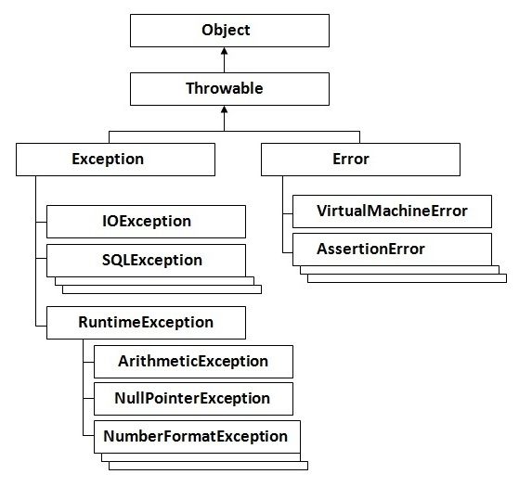

# Types of Exception

There are mainly two types of exceptions: checked and unchecked where error is considered as unchecked exception. The sun microsystem says there are three types of exceptions:

1. Checked Exception
2. Unchecked Exception
3. Error

## Difference between checked and unchecked exceptions

### 1) Checked Exception

The classes that extend Throwable class except RuntimeException and except Error are known as checked exceptions e.g.IOException, SQLException etc. Checked exceptions are checked at compile-time.

### 2) Unchecked Exception

The classes that extend RuntimeException are known as unchecked exceptions e.g. ArithmeticException, NullPointerException, ArrayIndexOutOfBoundsException etc. Unchecked exceptions are not checked at compile-time rather they are checked at runtime.

### 3) Error

Error is irrecoverable e.g. OutOfMemoryError, VirtualMachineError, AssertionError etc.

# Java Exception Handling Keywords

There are 5 keywords used in java exception handling.

1. try
2. catch
3. finally
4. throw
5. throws

#### Rule: For each try block there can be zero or more catch blocks, but only one finally block.

#### Note: The finally block will not be executed if program exits(either by calling System.exit() or by causing a fatal error that causes the process to abort).

Rule: try block must either come with catch or finally. Try cant come alone.

# Difference between final, finally and finalize

There are many differences between final, finally and finalize. A list of differences between final, finally and finalize are given below:

|  |  |  |  |
| --- | --- | --- | --- |
| **No.** | **final** | **finally** | **finalize** |
| 1) | Final is used to apply restrictions on class, method and variable. Final class can't be inherited, final method can't be overridden and final variable value can't be changed. | Finally is used to place important code, it will be executed whether exception is handled or not. | Finalize is used to perform clean up processing just before object is garbage collected. |
| 2) | Final is a keyword. | Finally is a block. | Finalize is a method. |

# Java Custom Exception Example

**class** InvalidAgeException **extends** Exception{

 InvalidAgeException(String s){

**super**(s);

 }

}